[Name of organization]
Overdose Prevention & Naloxone Policy and Procedures

Effective date: ______________

Table of Contents

- Purpose
- Policy
- Definitions
- On-Site Naloxone Use Procedures
- Distributing/Prescribing Naloxone to clients/patients/participants

Appendix 1: Standing Order Template
Appendix 2: Statewide standing order
Appendix 3: Intramuscular Kit Instructions
Appendix 4: Intranasal Kit Instructions
Appendix 5: Signed Proof of Naloxone Training
Appendix 6: Naloxone Distribution & Use Tracking Log

PURPOSE
The purpose of this policy is to provide approved staff with guidelines to administer and/or distribute naloxone in order to reduce fatal opioid overdose while engaging clients/patients/participants.

POLICY
It is the policy of (Your agency) for trained staff to administer and/or distribute naloxone, in accordance with state law and the medical director’s guidelines and oversight, to persons who may be at risk of experiencing or witnessing an overdose in order to minimize chances of death.

DEFINITIONS

EMS: Emergency Medical Services that provide pre-hospital emergency medical care; such practitioners provide out of hospital care for those with an illness or injury

Naloxone: An opioid antagonist and antidote for opioid overdose produced in intramuscular and intranasal forms

Opioids: Catchall term for prescription, synthetic, semi-synthetic, or natural opiate drugs

Opiates: Naturally derived drugs from the poppy plant, such as heroin, morphine, or opium

Opioid Overdose: An acute condition caused by the flooding of the opioid receptors in the brain by opioids. It can cause extreme physical illness, decreased level of consciousness, respiratory arrest, or death.

IM Naloxone: Refers to the intramuscular (IM) administration of naloxone, either from a vial and syringe (manufactured by Hospira) or an auto-injector (manufactured by Kaleo, branded Evzio)

IN Naloxone: Refers to the intranasal (IN) administration of naloxone, either

from a nasal spray device (manufactured by Adapt, branded Narcan) or a 2mg/2ml syringe with nasal adaptor (manufactured by IMS/Amphastar)

ON-SITE NALOXONE USE PROCEDURES

(Your agency) shall appoint a Naloxone Coordinator. The Naloxone Coordinator’s responsibilities will include:

Working with administrative medical director to create an agency-wide standing order for naloxone (see Appendix 1 for template)
    - Working with administrative pharmacy director (if applicable) to utilize statewide standing order for naloxone (see Appendix 2)

Collaborating with local partners to obtain naloxone, either directly or by prescription

Choose key areas to store naloxone, ensuring that storage temperatures do not exceed recommended range

Ensure that naloxone kits are current and not past expiration date

Ensure that authorized staff are adequately trained in overdose recognition, naloxone use, and storage (see subsections IV.D. and IV.E.)

Create and maintain naloxone use report form and log (see Appendix 6 for template)
    - Replace naloxone kits that are damaged, unusable, expired, or used.
    - If obtaining naloxone from Sonoran Prevention Works, the Naloxone Coordinator shall report the number and dates of all overdose reversals that occurred as a result of naloxone administered/distributed to Sonoran Prevention Works by the last business day of the month.

Each IM (intramuscular) naloxone kit shall include:

Instructions for administration of naloxone (see Appendix 3 for example);

Two IM syringes (preferably 22-25g, 1-1.5”, 3cc) and

Two vials 0.4mg/mL naloxone by Hospira; OR

One box Evzio auto-injector by Kaleo (complete with two devices);

Optional: One CPR face mask/barrier device for mouth-to-mouth resuscitation; one sharps container for disposal of IM syringes; two alcohol wipes to clean skin pre-injection in order to avoid bacterial infection.

Each IN (intranasal) naloxone kit shall include:

Instructions for administration of naloxone (see Appendix 4 for example);

One box Narcan nasal spray by Adapt (complete with two devices); OR

Two vials 2mg/2mL naloxone by Amphastar and

Two 2mL Luer-Jet Luer-Lock needleless syringe and

Two mucosal atomizer devices (MAD-300);

Optional: One CPR face mask/barrier device for mouth-to-mouth resuscitation

Indications and Use

Authorized staff shall check for responsiveness if client/patient/participant is believed to be suffering from an opioid overdose. Information that a client/patient/participant is suffering from an opioid overdose includes, but is not limited to:

No response to external stimulation, such as a sternum rub

Blue or gray skin, lips, or fingertips

Depressed or slow respirations

Difficulty breathing (labored, shallow, or halted breaths)

Decreased pulse rate

Pinpoint pupils, even in a darkened environment

Evidence of ingestion, inhalation, or injection (needles, cookers, tourniquets, needle tracks, aluminum foil, etc.)

Staff shall summon EMS by calling 911 and communicating that the patient is not breathing or in suspected overdose, and that naloxone administration is intended

Staff shall maintain universal precautions against pathogens by using latex gloves if using IM naloxone, and using a CPR face shield or barrier if performing rescue breathing.

Staff shall administer one dose of naloxone

If possible, staff shall begin rescue breathing for two minutes. Rescue breathing consists of one deep breath in the subject’s mouth every five seconds, ensuring that client/patient/participant is lying on their back, head is tilted up, and nose is plugged.

If no response after two minutes, staff shall administer second dose of naloxone and resume rescue breathing until client/patient/participant begins breathing on their own or EMS arrives

Staff shall ensure accurate communication to EMS for proper patient record documentation before transport to hospital emergency department

Supervisor notification should be made as soon as practicable

Documentation of naloxone use should be recorded.

Maintenance, Storage, and Replacement of Naloxone

Staff who use naloxone shall communicate with Naloxone Coordinator to ensure naloxone is replaced

Missing, damaged, or expired naloxone kits will be reported directly to the Naloxone Coordinator and replaced

Temperature storage:

IM Hospira kits store at 68-77°F

IM Evzio store at 59-77 °F, incursions permitted from 39-104 °F

IN Narcan spray store at 59-77 °F, incursions permitted from 39-104 °F

IN Amphastar kits store at 59-86°F

DISTRIBUTING/PRESCRIBING NALOXONE TO client/patient/participantS

Identifying client/patient/participants who may benefit from overdose prevention/naloxone training:

Clients/patients/participants with opioid use disorder diagnosis;

Clients/patients/participants with history of opioid use, abuse, or dependence;

Current opioid users;

Past opioid use and recent release from jail, prison, detox, inpatient, hospital, or after any period of sustained abstinence;
    - Friends or family members of any of the above.
    - Any person requesting naloxone.

Educating client/patient/participants on walk-in, intake, assessment, before release, or identify what point of time is best for education.

Identify client/patient/participant in need of overdose prevention/naloxone training

Ask client/patient/participant if they have witnessed or experienced an overdose, and what they know about overdose prevention

Review the 5 components of overdose risk:

Mixing drugs

Tolerance changes

Quality/purity

Physical health

Using alone

Teach client/patient/participant how to recognize an overdose:

No response to external stimulation, such as a sternum rub

Important! If a person does respond to a sternum rub, they are not necessarily in the clear. Overdose is a slow process, so they will require careful monitoring for 1-3 hours to ensure an overdose does not occur.

Depressed or slow respirations

Blue or gray skin, lips, or fingertips

Difficulty breathing (labored, shallow, or halted breaths)

Decreased pulse rate

Pinpoint pupils, even in a darkened environment

Evidence of ingestion, inhalation, or injection (needles, cookers, tourniquets, needle tracks, aluminum foil, etc.)

Educate client/patient/participant on naloxone information:

Only works on opioids, may not work on poly-drug OD

Wears off after 45-90 minutes, overdose may reoccur

Patient will be sick and may want to use again – some patients may become aggressive

Naloxone cannot hurt a person, except in rare cases of naloxone allergy

Educate client/patient/participant on naloxone use

Check for responsiveness with sternum rub

Call 911

Administer 1 dose of naloxone

Rescue breathe for two minutes

If no response, administer 2nd dose of naloxone

Continue to rescue breathe until paramedics arrive

Encourage client/patient/participant to report any use of naloxone for overdose reversal and to obtain a refill if used, lost, expired, stolen, or destroyed

Obtain signed document from client/patient/participant stating that staff trained them on overdose prevention, recognition, and response (see Appendix 5)

Prescribe or Dispense Naloxone

To prescribe: Prescription may be written to client/patient/participant by an MD, NP, PA, or DO

Staff will obtain prescribed naloxone for client/patient/participant, either directly at the pharmacy or from a delivering pharmacy and ensure that client/patient/participant receives the medication as soon as possible

AHCCCS covers intramuscular and intranasal; most other private insurances cover naloxone at about 90%

To dispense: Naloxone may be obtained through several avenues:

Staff can purchase naloxone for client/patient/participant from a pharmacist without a prescription, not covered by insurance.

Agency can collaborate with other community partners to receive naloxone kits for distribution to client/patient/participants with barriers to obtaining prescriptions or prescribed medication
      - Agency can dispense naloxone through a pharmacy and covered under client/patient/participant insurance with statewide standing order signed by ADHS Dr. Christ (see appendix 2)

As of January 2017, agencies can apply for donated product from Clinton Foundation (for Adapt Narcan nasal spray) or Kaleo (for Evzio auto injector)

If dispensing without a prescription, agency must use a standing order (see Appendix 1 and Appendix 2)

Tracking Naloxone Distribution and Reversal Reports
Recording naloxone prescription, distribution, and or reversal reports show success of the program and is very important keep a log with information, including but not limited to:

client/patient/participant name (OPTIONAL!)

Engagement/training date

Type of naloxone given (IM or IN)

Date prescription was written

Date prescription was filled or naloxone dispensed

Date of reported use for reversal and city of use

Information should be tracked and logged by Naloxone Coordinator. If partnering with an outside agency to obtain naloxone, report information to that agency.

Appendix 1
Standing order template

Sonoran Prevention Works (SPW)
Overdose Education and Naloxone Distribution Project

NALOXONE STANDING ORDER

Naloxone is indicated for the reversal of opioid overdose induced by natural or synthetic opioids in the setting of respiratory depression or unresponsiveness. It is contraindicated in patients known to be hypersensitive to naloxone hydrochloride.

This standing order covers the possession and distribution of naloxone kits, to include naloxone hydrochloride, intramuscular syringes, and overdose prevention materials, in conjunction with the SPW Overdose Education and Naloxone Distribution Project.

1. This standing order authorizes all trained staff and volunteers at the SPW Overdose Education and Naloxone Distribution Project to maintain supplies of naloxone kits for the purpose of using them to rescue a participant thought to be overdosing on opioids; and distributing them to a person at risk of experiencing an opioid-related overdose or to a family member, friend, or other person in a position to assist an individual at risk of experiencing an opioid-related overdose.

Order to Dispense
Upon satisfactory assessment that the person to receive the naloxone kit is a person at risk of experiencing an opioid-related overdose or a family member, friend, or other person in a position to assist a person at risk of experiencing an opioid-related overdose, and upon completion of training regarding recognizing and responding to suspected opioid overdose, dispense one naloxone kit, to include at a minimum:
- Two 1ml vials of naloxone hydrochloride
- Two intramuscular syringes
- Printed materials to include how to recognize and respond to suspected opioid overdose, how to use the device, how to dispose of syringes, and the importance of summoning emergency responders

The authorized dispenser will log all dispensed naloxone and overdose rescues on a form approved by the ordering physician.

Directions for Administration
administer naloxone to a person suspected of an opioid overdose with respiratory depression or unresponsiveness as follows:
- If practical, summon emergency medical services
- Remove lid from naloxone vial
- Insert syringe into vial and draw up 1ml of naloxone
- Administer 1ml of naloxone via intramuscular injection into upper arm, buttock, or thigh
- Initiate rescue breathing and monitor respiration and responsiveness of naloxone recipient
- If no response after 2-3 minutes, administer another 1ml dose of naloxone via intramuscular injection

_______________________________________ _____________________
Physician’s Signature and License No. Date

_______________________________________ __________________
Physicians Name (print) Order Expiration
Appendix 2
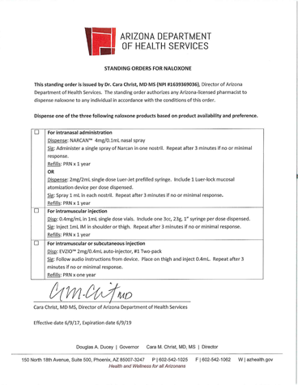

Appendix 3
Intramuscular naloxone instructions

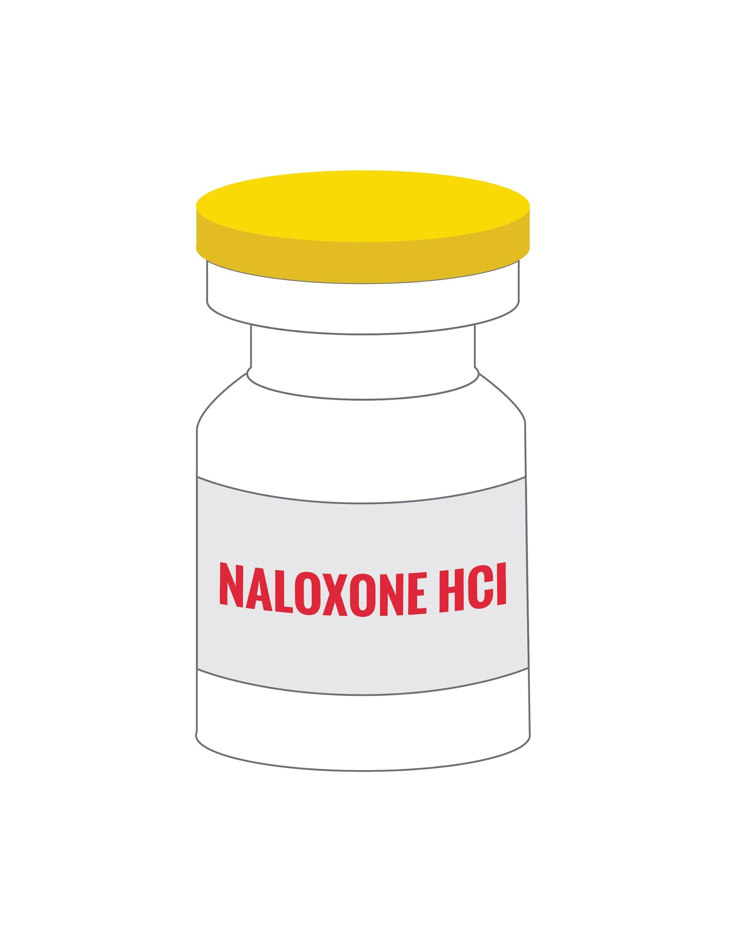
If you suspect an opiate overdose, rub the person’s sternum hard with your knuckles. If they do not respond to the pain, call 911, & then give the person naloxone.

- Pop the orange lid off of one vial. Stick an intramuscular 1” needle into the thin film & pull up all of the liquid. If you don’t have an intramuscular needle, you can use an insulin syringe, though it is not ideal.
- Stick that bad boy in your friend’s arm or thigh and inject all of the medication. No need to look for a vein.
- While you’re waiting for it to kick in, perform rescue breathing on the person. No need for chest compressions, just tilt their head back, plug their nose, and give a deep breath every 5 seconds.
- If the first dose doesn’t wake your friend up within 2 minutes, give them the second dose. Use a new syringe.
- Continue to rescue breathe for them until they can breathe on their own.
- Once they’re breathing on their own, place them on their side with their hand under their head.

Important info to know:

- Even with naloxone, your friend may still be at risk of death if they have taken a mixture of benzos (Xanax, Valium, etc.) or alcohol with the opiates, or if their opiates were cut with fentanyl or other long-acting opioids.

- Your friend will feel very sick when they wake up, as naloxone brings on immediate withdrawal. DO NOT LET THEM USE, even though they may want to. Otherwise they may overdose again. They may be at risk of overdosing again 1-3 hours after the naloxone wears off even if they don’t use, so get them medical attention.

- When calling 911: All you need to say is that your friend is not breathing. If the dispatcher asks why, you are not obligated to state it is an overdose. This will increase the likelihood that only the paramedics show up, not the police. Generally, the paramedics just want to help the person & leave, so make sure you tell them everything you know when they get there.

What puts you at risk of an overdose?

Overdose happens when the opiate receptors in your brain get so filled with opiates, that your breathing slows to the point of respiratory failure. When you stop breathing, your brain stops functioning, leading to death.

This usually happens when you take more opiates than your body can handle.

This occurs when:

- Your tolerance is lowered, due to recently getting out of detox, treatment, or jail
- You are using dope/pills that are stronger than you are used to, i.e. new cut, new dealer, higher mg
- Your immune system is weakened because you are sick or recently got over being sick
- You recently started injecting, or regularly switch between smoking/snorting & injecting
- You are mixing opiates with benzos (Xanax/Valium, etc) or alcohol – this is very dangerous!!

Ways to avoid overdosing:

- If you have a new source, or you have been using less or not at all, test it out!! You can always do more – but you can’t do less.
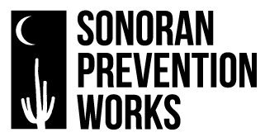
- Consider smoking or snorting instead of injecting so you know how strong it is.
- Try not to use alone. This way, if you fall out, there will be people around to witness it.
- If you are using alone, let people in the house know, if you can, & don’t lock the door.

For more naloxone and harm reduction info contact (480) 442-7086
www.spwaz.org

Appendix 4
Intranasal kit instructions

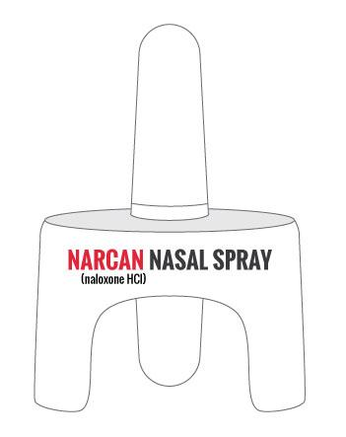
If you suspect an opiate overdose, rub the person’s sternum hard with your knuckles. If they do not respond to the pain, call 911, & then give the person naloxone.

- Lay your friend on their back.
- Peel the silver backing off of the Narcan package.
- DO NOT test the device. Once you push the plunger, it all comes out at once and you will not be able to spray any more.
- Stick the tip of the device into your friend’s nostril and push the plunger, expelling all of the medication.
- While you’re waiting for it to kick in, perform rescue breathing on the person. No need for chest compressions, just tilt their head back, plug their nose, and give a deep breath every 5 seconds.
- If the first dose doesn’t wake your friend up within 2 minutes, give them the second dose. Use a new syringe.
- Rescue breathe for them until they can breathe on their own.
- Once they’re breathing on their own, place them on their side with their hand under their head.

Important info to know:

- Even with naloxone, your friend may still be at risk of death if they have taken a mixture of benzos (Xanax, Valium, etc.) or alcohol with the opiates, or if their opiates were cut with fentanyl or other long-acting opioids.

- Your friend will feel very sick when they wake up, as naloxone brings on immediate withdrawal. DO NOT LET THEM USE, even though they may want to. Otherwise they may overdose again. They may be at risk of overdosing again 1-3 hours after the naloxone wears off even if they don’t use, so get them medical attention.

- When calling 911: All you need to say is that your friend is not breathing. If the dispatcher asks why, you are not obligated to state it is an overdose. This will increase the likelihood that only the paramedics show up, not the police. Generally, the paramedics just want to help the person & leave, so make sure you tell them everything you know when they get there.

What puts you at risk of an overdose?

Overdose happens when the opiate receptors in your brain get so filled with opiates, that your breathing slows to the point of respiratory failure. When you stop breathing, your brain stops functioning, leading to death.

This usually happens when you take more opiates than your body can handle.

This occurs when:

- Your tolerance is lowered, due to recently getting out of detox, treatment, or jail
- You are using dope/pills that are stronger than you are used to, i.e. new cut, new dealer, higher mg
- Your immune system is weakened because you are sick or recently got over being sick
- You recently started injecting, or regularly switch between smoking/snorting & injecting
- You are mixing opiates with benzos (Xanax/Valium, etc) or alcohol – this is very dangerous!!

Ways to avoid overdosing:

- If you have a new source, or you have been using less or not at all, test it out!! You can always do more – but you can’t do less.
- Consider smoking or snorting instead of injecting so you know how strong it is.
- Try not to use alone. This way, if you fall out, there will be people around to witness it.
- If you are using alone, let people in the house know, if you can, & don’t lock the door.

For more naloxone and harm reduction info contact (480) 442-7086 www.spwaz.org

Appendix 5
Signed proof of naloxone training

Trainer Initials
The most common drugs identified in an opioid-related death (heroin, oxycodone, hydrocodone, fentanyl) and the physical effects these drugs have (slow, shallow, irregular breathing; low pulse; euphoria; unconsciousness)
The main causes of drug overdose (low tolerance, polydrug use, using too much, using alone, injecting drug use, purity levels, adulterants like fentanyl)
High-risk times (release from prison/jail, leaving rehab or hospital, recent detox, recent relapse, poor physical or mental health, new source, recent significant life events, cash windfall)
The signs & symptoms of suspected opiate overdose (slowed/irregular breathing, blue/gray skin/lip color, no response to noise or touch, loss of consciousness)
The common myths (Don’t: inflict pain, “balance out” with other drugs, put in bath/shower, ice down the pants, sleep it off)
Knows how and when to call 911 (“Person is not breathing” rather than reporting overdose to dispatcher; call 911 before administering naloxone)
Knows when and how to administer naloxone (After non-responsiveness to stimuli. Second dose if not responsive after 2 minutes. Review different naloxone devices.)
Knows about rescue breathing (Clear airway. Pinch the person’s nose, tilt head back, and give deep breaths every five seconds. No need for chest compressions.)
Knows about the recovery position (person on side, airway open)
Knows that naloxone is short acting (the effects of naloxone wear off after 45-90 mins, possible that overdose may return)
Knows the importance of staying with the person (do not let the person use any other drugs if they gain consciousness, monitor for relapse into respiratory arrest)
Knows the importance of not re using the product or the needle once the pack has been opened and how to dispose of used syringe if intramuscular naloxone was used.
Knows that developing a plan is important (raising awareness about Naloxone access and OD prevention)
Has been informed where to receive naloxone (doctor, community organizations, pharmacies)

Review: I verify I have received the training outlined above:
Printed Name______________
- Check for responsiveness Signature:_______________
- Call 911 Date: __________________
- Give 1st dose of Naloxone
- Rescue breathe for 2 minutes
- Give them a 2nd dose, if no response
- If you must leave, put them in the recovery position
- Transfer care to EMT or Emergency Department
- Monitor to make sure they do not overdose again

Appendix 6
Naloxone distribution & use tracking log

Overdose Education & Naloxone Distribution Tracking
Distribution site:
client/patient/participant name: | Trainer name: | # & type of kits prescribed: | Date prescription written: | Date client/patient/participant obtained naloxone: | Date of reported use: | Location of reported use: | Naloxone used by whom:

