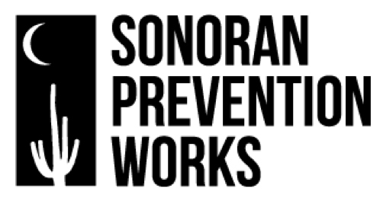
Incorporating Overdose Prevention Programming
Sonoran Prevention Works believes in a harm reduction approach to mitigating the individual & community impacts of drug use. We meet people where they are, and we extend that philosophy to the treatment facilities with whom we work, as well. As such, we applaud those who choose to incorporate the overdose prevention programming outlined below, regardless of which level is right for your facility at this time. However, please keep in mind that facilities choosing to become Overdose Prevention Pros will receive more frequent and ongoing interaction from SPW Staff, while those opting for the Bare Minimum will receive less.

Overdose Prevention Programming Options
Bare minimum: Provide education on how to prevent overdose and the benefits of naloxone at intake or assessment with clients/patients, and refer to resources for obtaining naloxone.

One Step Up: Provide education on how to prevent overdose and how to use naloxone at intake or assessment with clients/patients, and write clients/patients prescription for naloxone to be filled at pharmacy upon discharge.

Getting Better: Provide education on how to prevent overdose and how to use naloxone at intake or assessment with clients/patients. Write clients/patients prescription for naloxone, and ensure clients/patients obtain medication during visit by using a pharmacy that delivers or by picking medication up for clients/patients, ensuring clients/patients have naloxone in hand at discharge.

Overdose Prevention Pro: Provide education on how to prevent overdose and how to use naloxone at intake or assessment with clients/patients. Write clients/patients prescription for naloxone, and ensure clients/patients obtain medication by using a pharmacy that delivers or by picking medication up for clients/patients during visit. Confirm that clients/patients have naloxone in hand or in belongings at intake or first assessment. If the facility is inpatient or residential, naloxone should be readily available where patients sleep. For those without insurance or when insurance is a barrier, organization covers cost of naloxone or contacts SPW to provide naloxone kits for these types of patients/clients.

Ready to reduce harm? The process is simple and proceeds as follows:
- Facility notifies SPW of their intent to implement one of the above options.
- SPW provides a Policies & Procedures template to aid facility in making it official.
- Once facility creates policy around overdose prevention, SPW Staff will provide and/or facilitate initial training.
- SPW trainings are intended to be internally sustainable (“Train the Trainer”-style), so facilities should ensure that potential Trainers are able to attend the initial training.

Peer Training
SPW also recommends that, in addition to the options outlined above, your facility consider inviting SPW Staff to lead a Peer Training on overdose prevention. Since the majority of overdoses occur in a personal residence, empowering people who use drugs to perform reversals on one another has great life-saving potential.

Contact SPW for further information, training, and assistance.
www.spwaz.org – 480-442-7086 – info@spwaz.org

